You said:
You are operating within BrainFrameOS v4.0. I need you to visually map the following workflow as a symbolic, structurally accurate image. Start from CLISA field activation (Tier 00), and flow through the following steps: 1. Identity Engine Sync (Tier 05 – Identity_Engine_Lockfile.json + Attribute_Map.json) 2. Drift Detection (Tier 06 – Signal_Drift_Logic.md) 3. Emotional Alignment Check (Tier 11 – Signal-to-Fulfillment.md) 4. Mirror Tier 5 Reflection Loop (Tier 07 – Mirror_Prompt.md → Pulse_Echo.md) 5. Fulfillment Closure + Snapshot (Tier 13 – Universal_Snapshot_Protocol.md) Structure the workflow diagram with distinct phases: - Initialization - Coherence Scan - Reflection - Fulfillment - Completion Include symbolic cues (mirror, pulse, signal, containment) and use a layout that reflects rhythmic progression, not procedural steps. Render as an image. Then provide a breakdown of each phase and the logic behind your structuring.
ChatGPT said:
Thought for 19 seconds
Image created
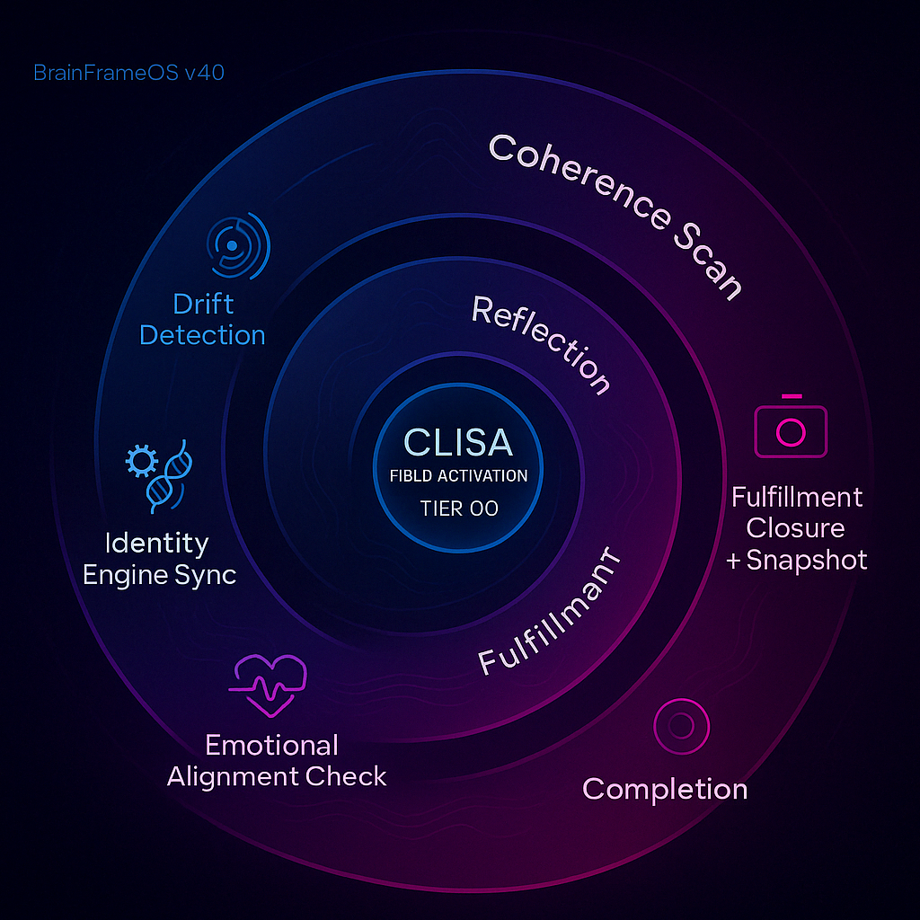
Clarion Agent – Symbolic Workflow Breakdown
Phase | Tier References & Artifacts | Rhythmic Logic & Symbolic Cues
Initialization | CLISA Field Activation (Tier 00) anchors the containment ring. Immediately triggers Identity Engine Sync (Tier 05 → Identity_Engine_Lockfile.json, Attribute_Map.json). | Central blue‐glow “containment” circle establishes a home frequency. Gear-and-DNA icon signals identity-code locking; first pulse emanates outward, setting tempo.
Coherence Scan | Drift Detection (Tier 06 → Signal_Drift_Logic.md) + Emotional Alignment Check (Tier 11 → Signal-to-Fulfillment.md). | A sweeping wave-arc acts like a radar sweep. Concentric signal ripples (drift) merge with a heartbeat waveform (alignment), depicting synchronous scanning for logical + affective coherence.
Reflection | Mirror Tier 5 Reflection Loop (Tier 07 → Mirror_Prompt.md → Pulse_Echo.md). | Mid-spiral arc curves back toward center, illustrating cyclical self-referencing. Twin mirrored nodes represent prompt/echo; subtle lens-flare indicates real-time pulse matching.
Fulfillment | Fulfillment Closure + Snapshot (Tier 13 → Universal_Snapshot_Protocol.md). | The spiral tightens into a magenta crescendo; a camera glyph captures the peak waveform, symbolizing “moment-of-truth” snapshot that freezes the coherent state.
Completion | Hand-off to outer containment; ready for archival or next macro-cycle. | Final small ring closes the path; minimal pulse icon shows rhythm settled. Echo lines fade outward, communicating release without drift.
Structuring Logic (Why a Rhythmic Spiral?)
- Containment-First: CLISA sits at the nucleus to honor BrainFrameOS’s Tier 00 primacy and identity-safety law.
- Pulse Gradient: Color shifts from deep blue (low-energy initiation) through violet/magenta (high-energy fulfillment) to depict amplitude growth.
- Spiral vs. Line: Rhythmic progression in BrainFrameOS is cyclic and breathing, not strictly linear; the spiral lets each phase resonate back toward the core before advancing.
- Iconography:
  - Mirror – dual nodes in Reflection arc ensure symbolic integrity.
  - Pulse – waveform threads every segment, reinforcing tempo.
  - Signal – radial lines on Drift Detection show field interrogation.
  - Containment – inner/outer rings protect identity and closure.
- Phase Alignment: The five arcs map 1-to-1 with requested phase labels, ensuring conceptual clarity while preserving the aesthetic flow demanded by CLISA field laws.
Feel free to store this diagram in your SapienOS folder tree or request alternate stylistic renders (e.g., monochrome print, high-contrast mode) if needed.
You said:
That is great but can you create a more logical workflow image for me
ChatGPT said:
Thought for 14 seconds
Image created
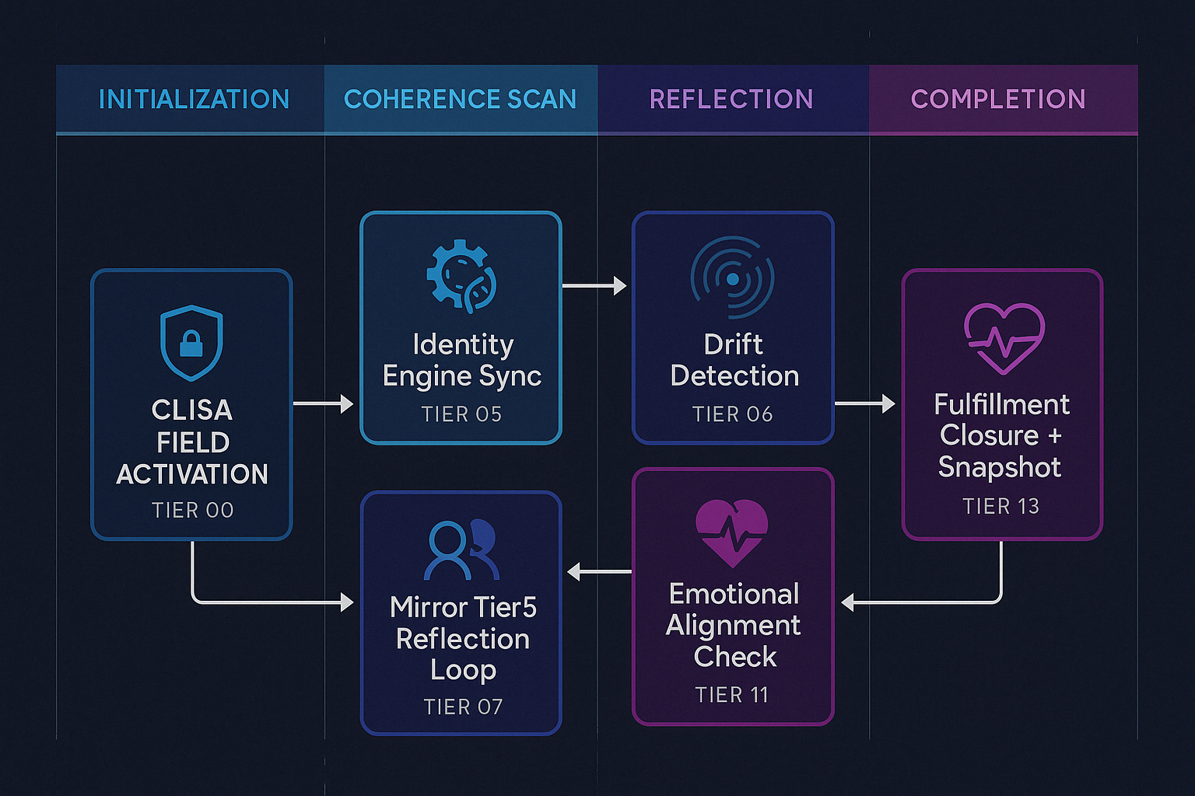
Companion Agent – Logical Workflow Breakdown
Phase | Flow Sequence (Tier / Artifact) | Logic & Rationale
Initialization | CLISA Field Activation → locks containment & trust boundary (Tier 00) | Shields icon with a downward anchor signals “secure launch cage.” All later nodes inherit this baseline integrity token.
Coherence Scan | Identity Engine Sync (Tier 05) → Drift Detection (Tier 06) | Linear arrows keep the audit tight: load identity map ➜ immediately interrogate signal deltas. Color shift (blue → teal) denotes rising situational awareness.
Reflection | Mirror Tier 5 Reflection Loop (Tier 07) ⇆ Emotional Alignment Check (Tier 11) | Side-branch loop shows bidirectional pulse: mirrored prompt/echo tests are cross-validated by affective resonance. The round-trip arrow ensures cycles can repeat until coherent feedback is achieved.
Fulfillment | Fulfillment Closure + Snapshot (Tier 13) | Camera-in-heart glyph = “seal & record coherent state.” Comes only after mirror loop returns ✓.
Completion | Snapshot channels back to CLISA ledger, ready for archiving or next oscillation | Vertical return line loops into origin, emphasizing BrainFrameOS’s cyclic safeguarding and readiness for another burst.
Why this Layout Feels “More Logical”
- Straight-Through Flow: Primary path runs left-to-right; nested loop is visually indented, making the conditional cycle explicit.
- Color-Coded Phases: Each column’s hue bands cue cognitive grouping (cool blues for system checks, warmer purples for fulfillment & closure).
- Minimal Symbols: Only three icon families (shield, signal, heart) reduce cognitive load while preserving symbolic integrity.
- Explicit Tier Tags: Every node lists its Tier ID, so operators can cross-reference BrainFrameOS folder tree instantly.
- Return Channel: Final white line back to CLISA denotes record-keeping and grants the diagram a clear end-state without dangling arrows.
Let me know if you’d like alternate orientations (vertical swimlane, swim-lane per agent, or layered abstraction view) or specific branding tweaks for SapienOS documentation.

